AP Macro Handout: Week 1

Unit 1

1.1 Scarcity
- Macroeconomics or microeconomics?
- What determines the overall trade in goods, services, and financial assets between the United States and the rest of the world? Macro
- What determines the number of iPhones exported to France? Micro
- What government policies should be adopted to make it easier for low-income students to attend college? Micro
- What determines the cost to a high school of offering a new course? Micro
- What determines the overall level of prices in the economy as a whole? Macro
- What government policies should be adopted to promote employment and growth in the economy as a whole? Macro
- What is the difference between macroeconomics and microeconomics?
Macroeconomics is concerned with the whole economy.
Microeconomics is concerned with individuals or groups within the economy.
- Human wants are limited or unlimited?
Unlimited
- Our resources are limited or unlimited?
limited
- What is the fundamental economic problem?
Unlimited wants but scarce/limited resources.
- Because of this we have make _____________ with how we use our resources.
Choice
- Give an example of a positive statement.
China’s economic growth rate has been one of the highest in the world over the last 50 years.
- Give an example of a normative statement.
Economic growth is the most important thing in our society.
- What are the four factors of production?
Land, labor, capital, enterprise
- Which of the factors of production is responsible for allocating (determining the use of) the other factors of production?
Enterprise – entrepreneurs are responsible for deciding how resources are used. (Though they can also employ labor to do this for them.)
- What are the names of income for:
Labor
Land
Capital
Enterprise
Wages
Rent
Capital
Profit
- What are the three questions in an economic system?
What to produce. How to produce. For whom to produce.
- What are 3 economic systems?
Free Market/Market/Capitalism, Planned/Command/Socialism, Mixed
- Most countries have a ____________ economic system.

1.2 Opportunity Cost, PPC
- What is the definition opportunity cost?
When we make a choice, the opportunity cost is the next best opportunity foregone.
The second best choice we would have made.
- Give an example of opportunity cost (it can be in a business context or a personal, everyday example).
You choose to study in the United States. Your opportunity cost is studying in Canada.
- What does PPC stand for? Ie. PPC = P________ P_________ C______
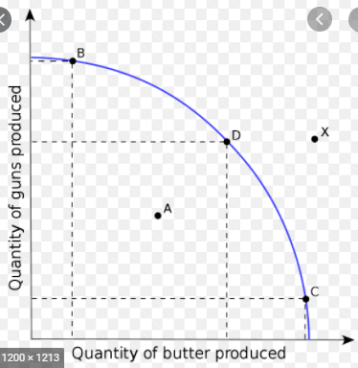
- Draw a PPC.

Label points that are: Inefficient, Efficient, Unattainable
- Why is the PPC often curved? Give an example why.
Because of increasing opportunity cost. Resources are not equally good at producing different products.
Eg. If a pizza chef is forced to make computers they may produce only a few computers and give up many pizzas, so the opportunity cost will be very high.

